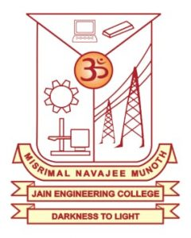
MISRIMAL NAVAJEE MUNOTH
JAIN ENGINEERING COLLEGE
(DEPARTMENT OF
MANAGEMENT STUDIES)

MBA
NEWS LETTER
JULY 2019 – MAY 2020

MBA DEPARTMENT – INTRODUCTION:

Department of Management Studies was started in the year 2005 and is functioning effectively to create efficient Business Managers.
Department vision
To produce high quality manager and entrepreneurs who are creative ethical with humility to contribute continuously to the development of the society.
Department Mission:
- To create knowledge hub of managers with everlasting urge to learn by developing , maintaining and continuously improving the resources.
- To educate the future managers with knowledge, skills & abilities necessary to adapt to continuously changing the business environment .
- To develop effective entrepreneurs, innovative corporate leaders and manager for facilitating and enhancing the global competiveness of organization through excellence in education , training & consultancy.
- To produce the ethical managers by instilling the value of humility, humanness, honesty and courage to serve the society.
- Preparing the students to fulfill their professional obligations with a high sense of duty consciousness in their carrier.

GUEST LECTURES / ASSOCIATION ACTIVITIES ORGANIZED BY VARIOUS CLUBS:
- Mr.Abishek Chandamarakshan, Senior Manager,VY Systems Pvt Ltd, Chennai, delivered a Guest Lecture organized by Marketing Club on “Current Trends in Marketing” to our II Year MBA students on 31st July 2019.

- Mr.Arvind Jayakumar, Senior Manager Finance, Born Commerce Pvt.Ltd, Chennai, delivered a Guest Lecture organized by Finance Club on “Emerging Trends in Financial Services Sector” to our II Year MBA students on 17th August 2019.

- Inauguration: Dr.C.Chandrasekar Christopher, Principal Inaugurated for I year MBA, Misrimal Navajee Munoth Jain Engineering College, was held on 04th September, 2019 in the A/C seminar hall. The function started with a prayer song. Dr. Abirami.P, Asso.Professor & Head welcomed the gathering and addressed by our Principal.

- Mrs.Uma Krishnamurthy, Tata Consultancy Services, Soft Skill Trainer, delivered a Guest Lecture organized by HR Club on the Topic “Smarter Recruitment” to our I & II year MBA students on 5th September 2019.

- Dr.CMA.Prema Manoharan, Retd from Indian Bank delivered a Special Lecture organized by Finance Club on the Topic “Special Lecture on E-Banking” to our I & II year MBA students on 19th September 2019.

- Mr.Narendran, Associate Manager, Service Marketing- Lanson Toyota , inaugurated “Gallant Managers Association” and delivered a Guest Lecture on the Topic “Process of Service Marketing” to our I & II year MBA students on 20th September 2019.

- Mr.Hariprasad Parthasarathy, Head- Analytics & Digital Marketing, Born Commerce Pvt.Ltd,Chennai, delivered a Guest Lecture organized by Marketing Club on “Why Digital Marketing is an Essential skill for next Gen Workforce” to our MBA students on 13th February 2020.

- Mr.Manoj, HR Executive, Career Net Consulting PVT Ltd invited as a Guest to Valedictory Function of ZEST 2020 – Inter-Collegiate Management Meet on 27.2.2020.

- Dr.Raghu Raman, CEO, MIRA Firm delivered a webinar on “ Career Opportunities After MBA” to passed out UG students on 14th July, 6.30 to 7.30 pm.

STUDENTS PARTICIPATED ACTIVITIES:

- Ms.Kuntrapakkam Yamini, Ms.Naveena.M, Ms.C.Divya, and MS.G.Devapriyanga of MBA participated in “Inter Collegiate Competition” held at D.G. Vaishnav College, Arumbakkam on 18th September 2019 on Mobile Photography, Business Quiz and Treasure Hunt.
- Mr. Pravin Kumar.R & Mr.Ganish Kannan.D of MBA participated in “Inter Collegiate Competition” held at Jerusalem College of Engineering, Pallikaranai, on 27.9.2019 in Business Quiz.
- Ms.Muthushenabagapriya, Ms.Nimisha, Mr.Pravin .S, Mr.Ram Kishore, Mr. Rohinth Krishna & Mr.Jayarajan participated a “Workshop in Career Planning” held at St.Joseph’s College of Engineering on 4.3.2020.
- Mr.Pravin Kumar.R, Mr.Gokulakrishnan, Mr.Rohinth Krishna, Mr.Pravin .S, Mr.R.Karthick, Mr.Abinash, Mr. K. Karthik, Mr.Naresh and Mr. Vivekh`participated in “Blood Donation Camp” organized by YRC on 5.3.2020.

ALUMNI ACTIVITY:

- Mr.D.Sugumar, Senior Sales Executive, Kwality Milk Foods Ltd, Kancheepuram delivered a Guest Lecture on “Skill Sets & Job Opportunities to Management Students in Marketing” to our II Year MBA students on 19th July 2019.
- Mr.K.Prakash, HR-Asst Manager, Muthoot Finance delivered a Guest Lecture on “Opportunities in HR & Marketing” to our MBA students on 29th January 2020.
- Ms.S.Karpagam, Transaction Process Associate, Accenture delivered a Guest Lecture on “Opportunities in Finance & Investment Banking” to our MBA students on 31st January 2020.

INDUSTRIAL VISIT:

- Industrial Visit: I & II MBA Students went to “The Diamond Engineering Pvt Ltd” Plant 1 – Kelambakkam & Plant 2 Mambakkam on 18th October 2019.

UNIVERSITY RANK: Ms.Yogasudha.S secured University 7th Rank, 2019.

INTER – COLLEGIATE MANAGEMENT MEET :
Department of Management Studies organized Intercollegiate meet “ZEST 2020” on 27th February 2020. 205 students from 18 different Arts & Science colleges were participated in this programme. The Programme was well received by the participants.
Dr.C.Chandrasekar Christopher, Principal launched “ZEST 2020 “ and delivered a motivational speech and highlighted the salient features about the college and the Department of Management Studies.

There were eight events in the programme which are listed below
- Business Quiz
- Connection
- Poster Making
- Fireless Cooking
- Vegetable Carving
- Solo Singing
- Face Painting
- One Minute Challenge

Valedictory Programme was conducted in the evening. Mr.Manoj, HR Executive from Career Net Consulting Private Limited was invited as the Chief Guest. He gave a motivational speech on the career guidance. Winners were awarded with Cash Prizes and certificates were given to the participants.
Mr.Sridhar, from Chennai Amirtha was invited as the Judge for Vegetable carving event at “ZEST 2020”.
Mrs.Rajalakshmi, invited as the Judge for Solo singing event at “ZEST 2020”.

Placement and Training Details (2019-2020)

S.NO | Student Name | Class | Company Name
1 | Eswar.S | II MBA | Kotak Life
2 | VinithRaja.B | II MBA | Kotak Life
3 | Abdul Halim.V | II MBA | Muthoot Finance
4 | Dhakshinamoorthy.G | II MBA | Muthoot Finance
5 | Dinesh Kumar.R.J | II MBA | Muthoot Finance
6 | Pradeep Kumar.B | II MBA | Muthoot Finance
7 | Muthukumar.B | II MBA | Accenture

REPORT CLOSURE:

- No of Guest Lectures |  | 06
- Marketing  - HR  - Finance | 02  02  02
- Industrial Visits |  | 01
- Students Participated |  | 04
- Alumni Activities |  | 03
- Management Meet Activities |  | 01
- Webinar |  | 01
TOTAL |  | 16

HOD – MBA Signature of the Principal
Date – 4/01/2021

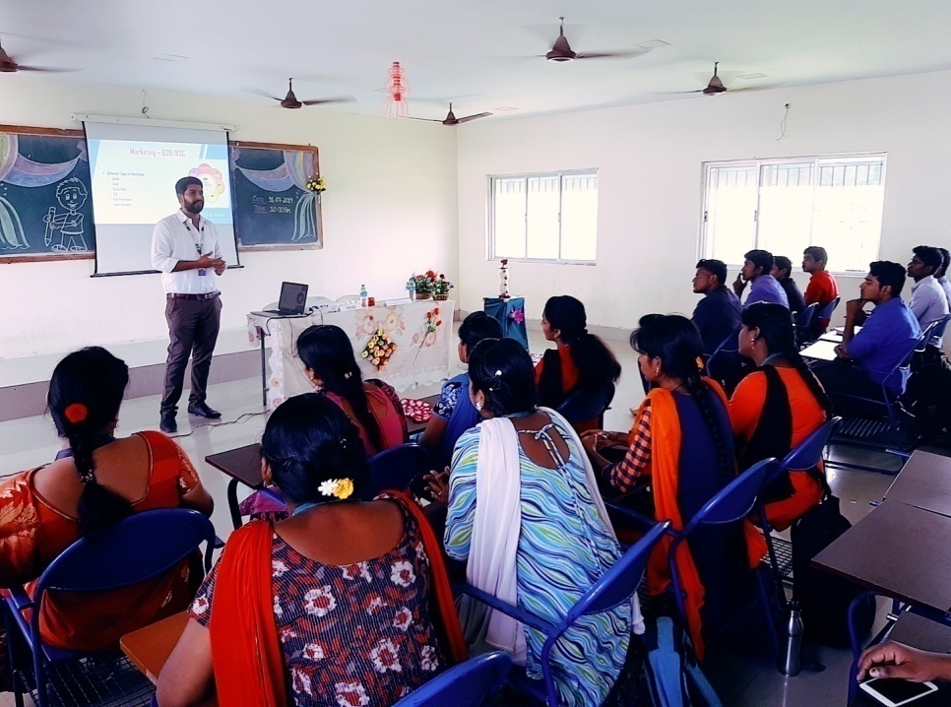

Guest Lecture about “Current Trends in Marketing” on 31st July 2019
(Marketing Club)

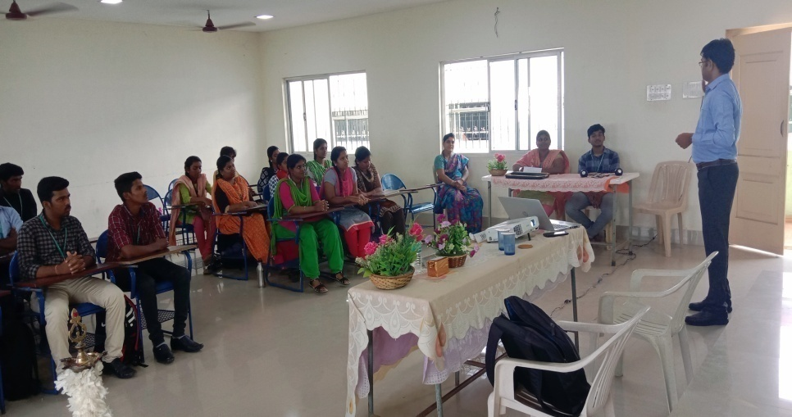
Guest Lecture about “Emerging Trends in Financial Services Sector” on 17th August 2019
(Finance Club)
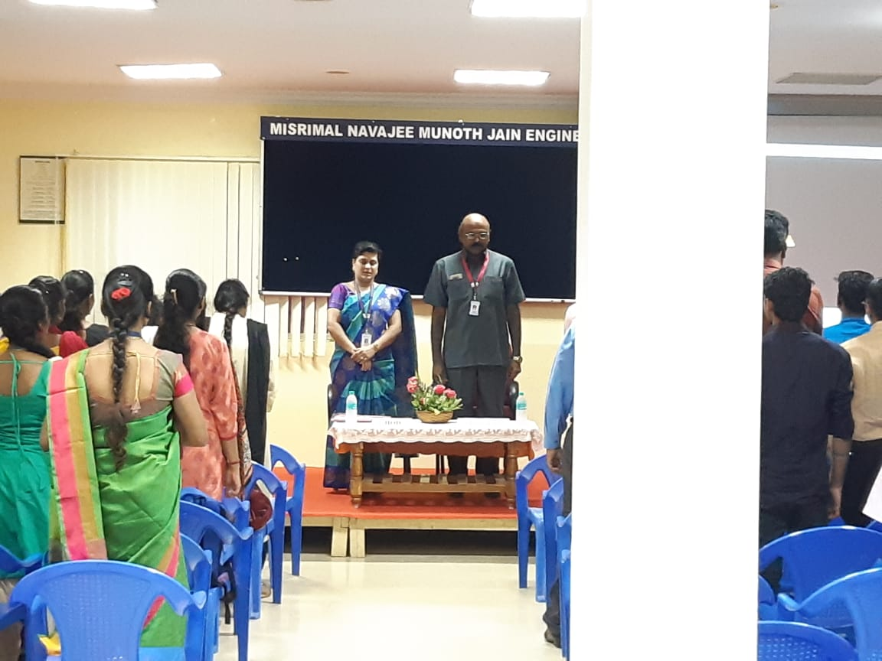
Inauguration for I year MBA on 04th September, 2019

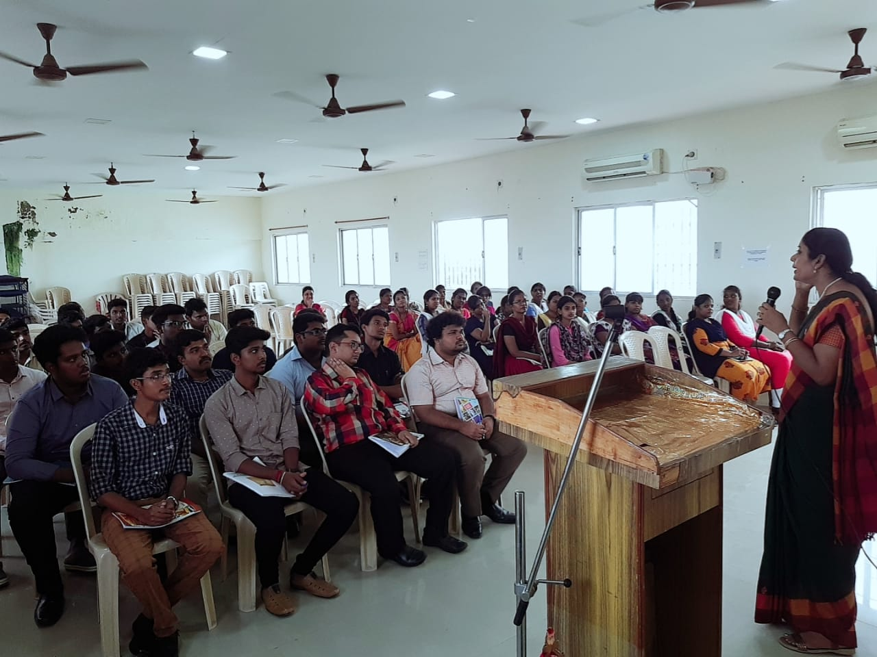
Guest Lecture about “Smarter Recruitment” on 5th September 2019 (HR Club)

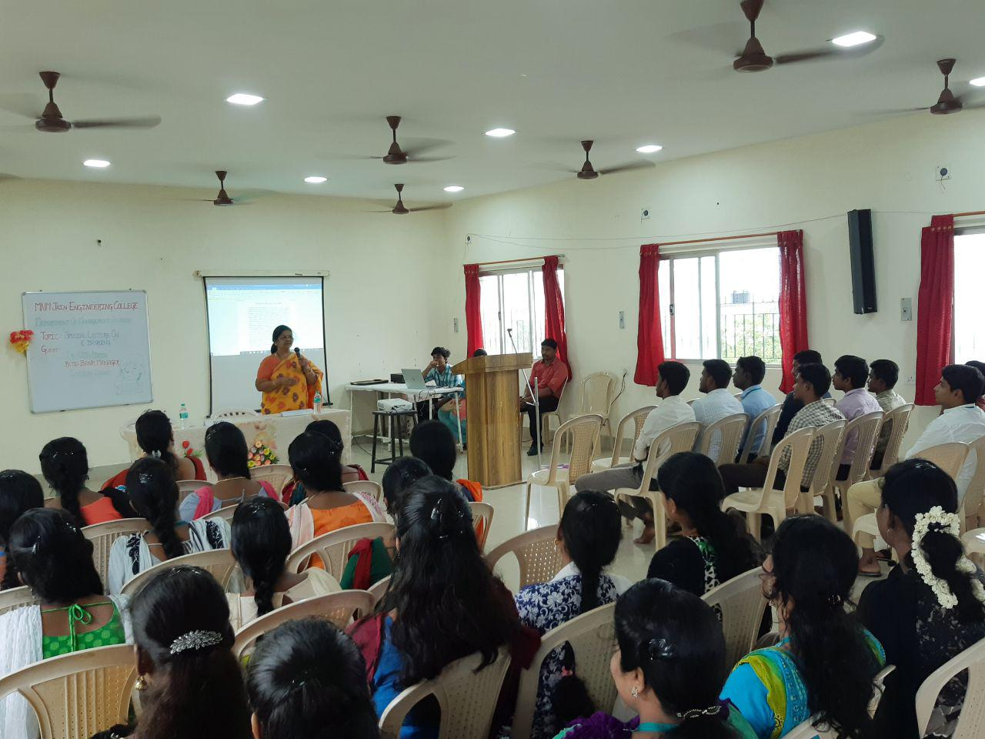
Special Lecture about “Special Lecture on E-Banking” on 19th September, 2019
(Finance Club)

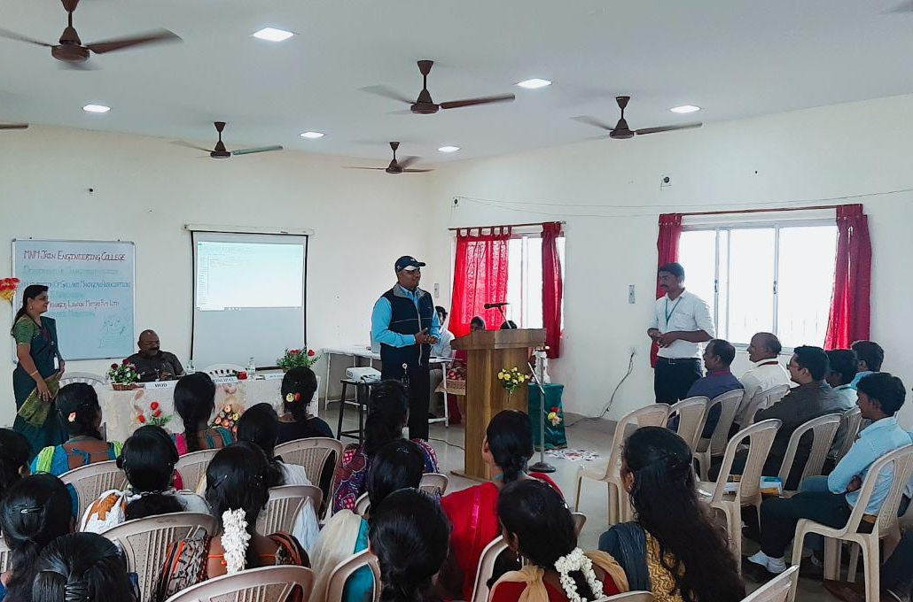
Guest Lecture about “Process of Service Marketing” on 20th September 2019
(Marketing Club)

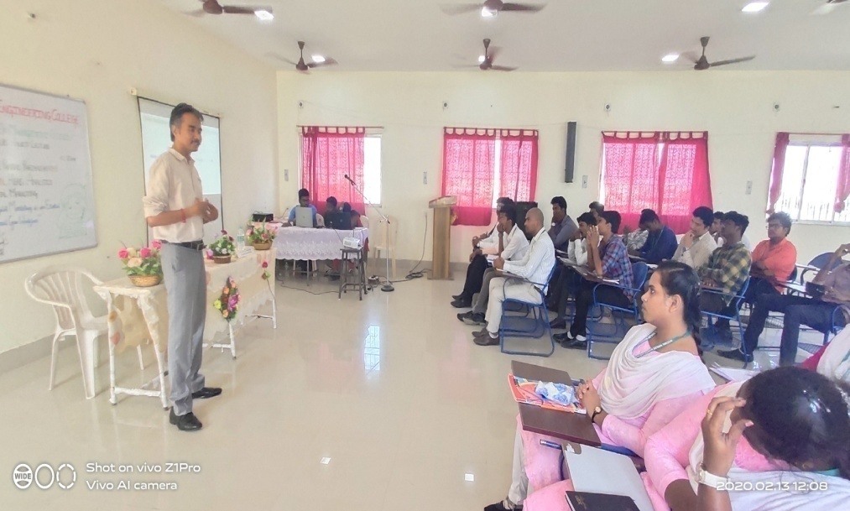
Guest Lecture about “Why Digital Marketing is an Essential skill for next Gen Workforce” 13th February 2020
(Marketing Club)

ALUMNI ACTIVITY
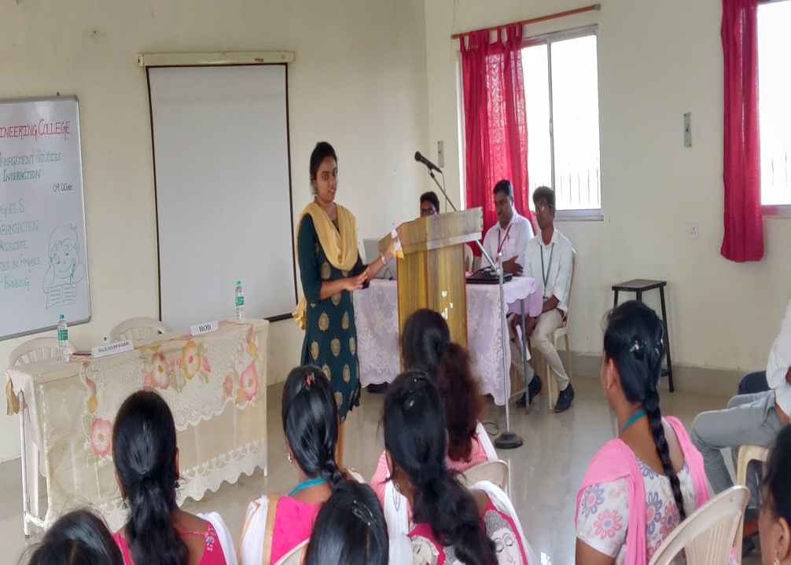
Ms.S.Karpagam, Transaction Process Associate, Accenture on 31st January 2020
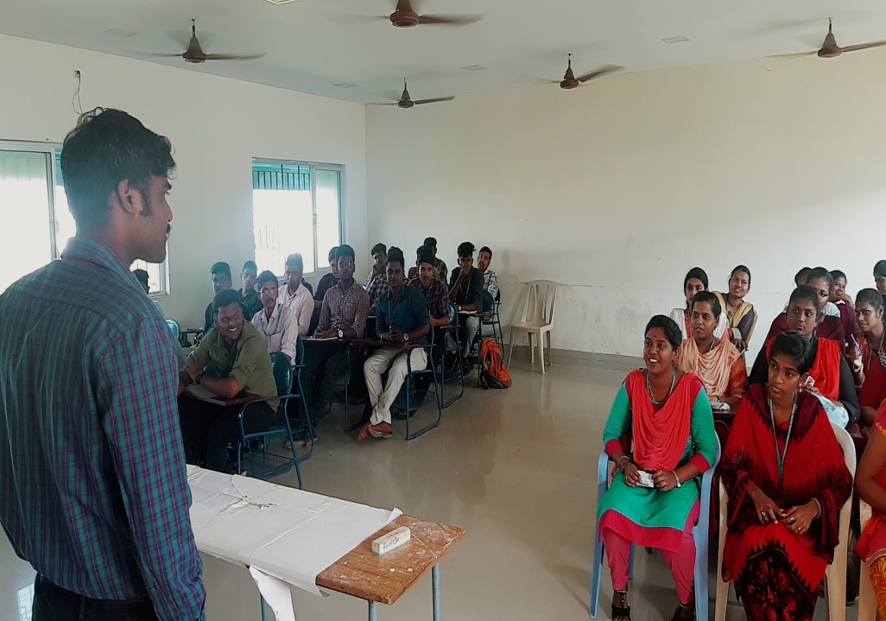
Mr.K.Prakash, HR-Asst Manager, Muthoot Finance on 29th September 2020

INDUSTRIAL VISIT
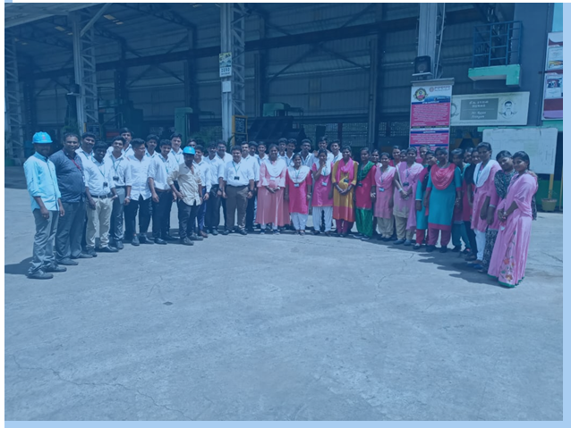
“The Diamond Engineering Pvt Ltd” on 18th October 2019

UNIVERSITY RANK
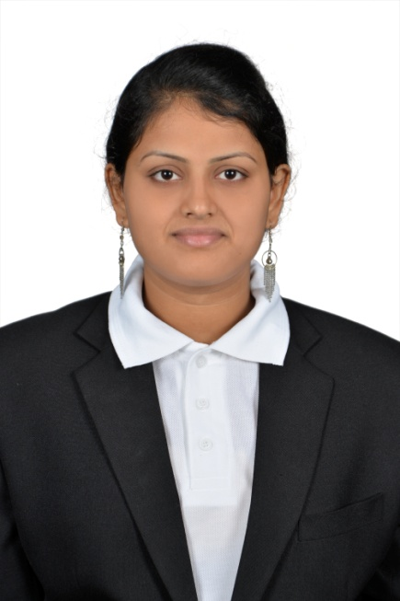
Ms.Yogasudha.S secured University 7th Rank, 2019

